Day 9 Lab

Images and Their Assigned tasks:
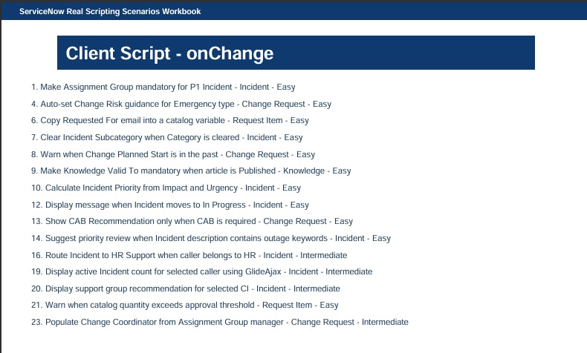
On change Tasks (10, 20)
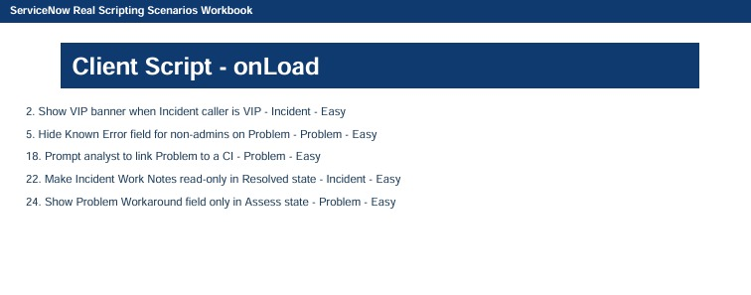
On Load Tasks (22,24)

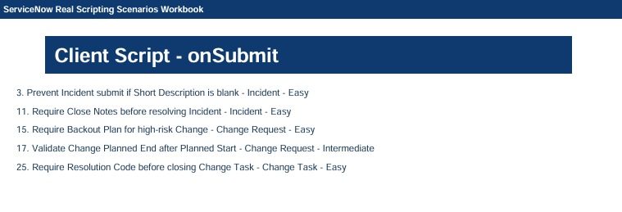
Onsubmit Tasks (3,11)

Answers Task 12:
Display Message when state is in progress (OnChange)
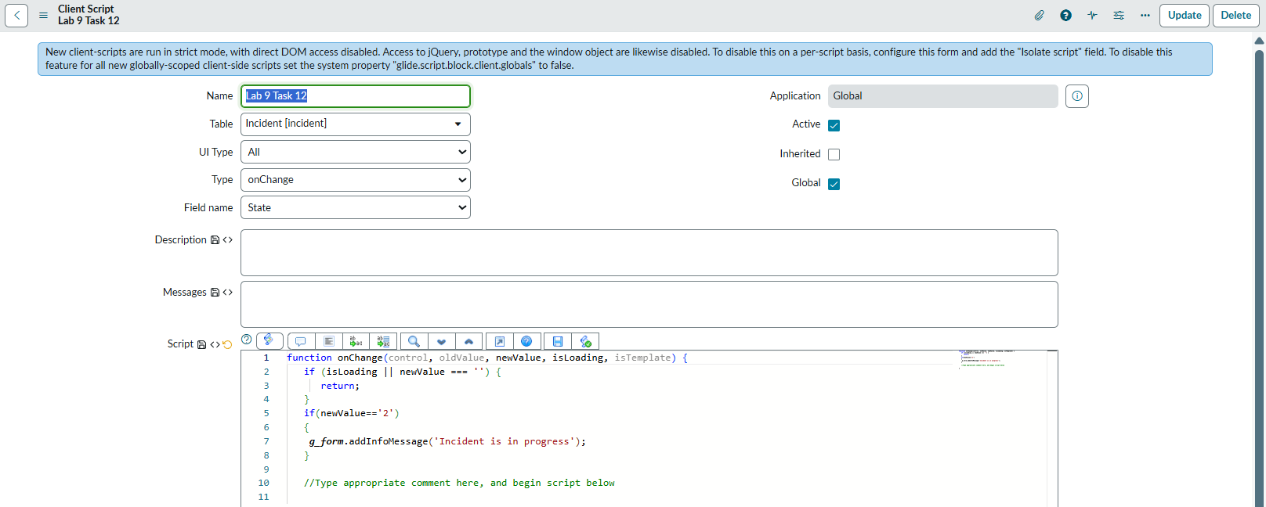

Answers Task 22:
Make Incident Work Notes read-only in Resolved state (OnLoad)
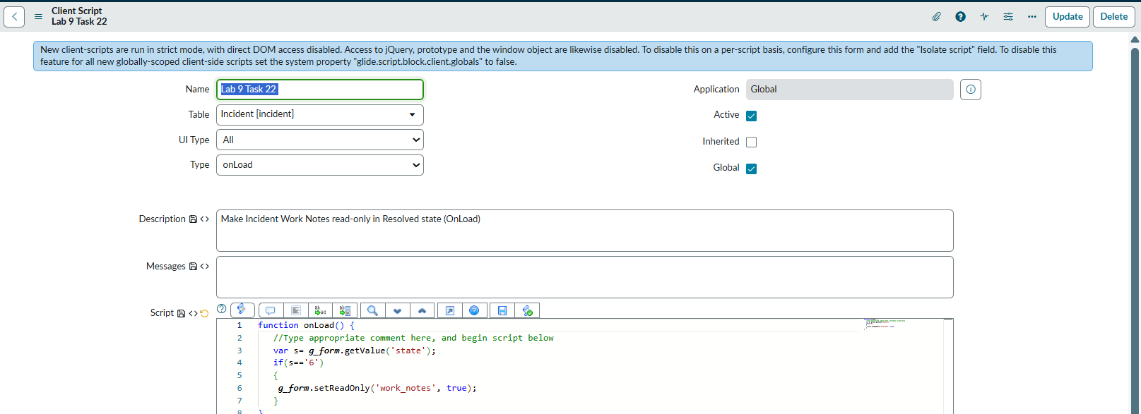

Answers Task 24:
Show Problem Workaround field only in Assess state (OnLoad)
